

MOUNT KENYA UNIVERSITY

SCHOOL OF COMPUTING AND INFORMATICS

BIT3208: Advanced Web Design and Development
Logbook Report

COVER PAGE

Student Details
Student Name:Zecky Bilgraham
Admission Number:BBIT/2024/58725
Course/Class: Bachelor of Business and Information Technology(BBIT)
Unit Code:BIT3208
Unit Name: Advanced Web Design and Development
Lecturer Name:Mr. Michael Nyoro
Semester/Academic Year:3.2

Project Details
Project Title: CheapMart – Smart E‑Commerce Web Application
Selected Technologies:PHP + MySQL, XAMPP, HTML5, CSS3, JavaScript, Git/GitHub

Online Portfolio / GitHub Link
GitHub Repository: https://github.com/zecky019-boop/cheapmart.git

Table of Contents
Week 1:Local Environment Setup
Figs:1. Installation of XAMPP
- Apache and MySQL Running
- Localhost Test Page
- Hello World Test
5. Database Connection Test

Week 2:Wireframes & GUI Design
Figs:1. Homepage wireframe
2. Dashboard Layout Design
3. Mobile View Mockup
4. Color Theme and Navigation Structure
5. GUI Prototype in Figma/Canva/Draw.io

Week 3:JavaScript & PHP Basics
Figs:1.JavaScript form validation-empty filled errors
- Password strength checker
- PHP Syntax Practice
- Database Connection Script
- Dynamic User Input Handling

Week 4:Server‑Side & Authentication
Figs:1. Registration form Successful
2. Login form in `login.php`
3. After successful login
4. Admin dashboard view
5. Session persistence
6. Folder structure of week 4
7. Week4db.sql

Week 5:Database & CRUD
Figs:1. phpMyAdmin showing the 5 tables
2. Hashed password row
3. DB login dashboard
4. Admin product list page
5. Add product form
6. Edit product page
7. Delete confirmation popup
8. Customer Product catalog
9. Week5db.sql

Week 1: Local Environment Setup
Title: Installation and Testing of Local Development Environment
Fig 1:Screenshot of XAMPP installer completed successfully.
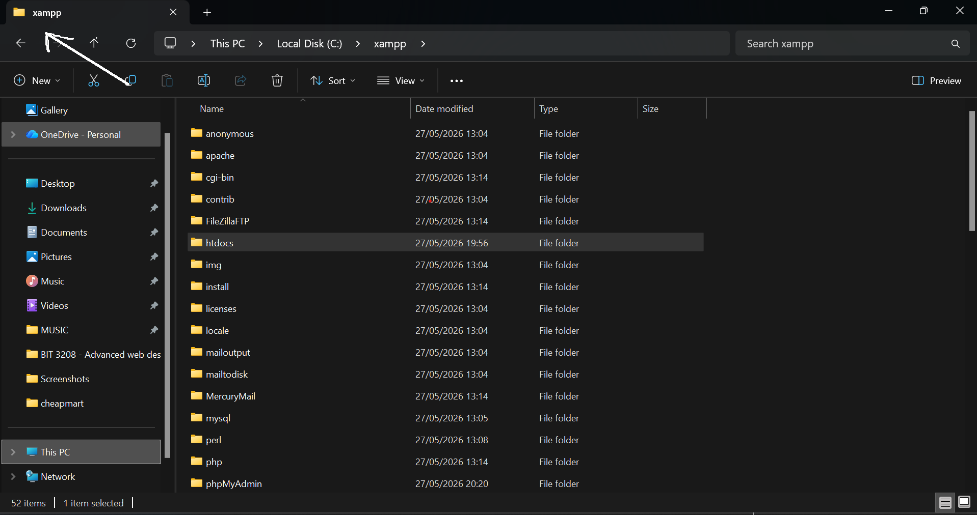
Fig 2:XAMPP Control Panel with Apache and MySQL running (green highlights).
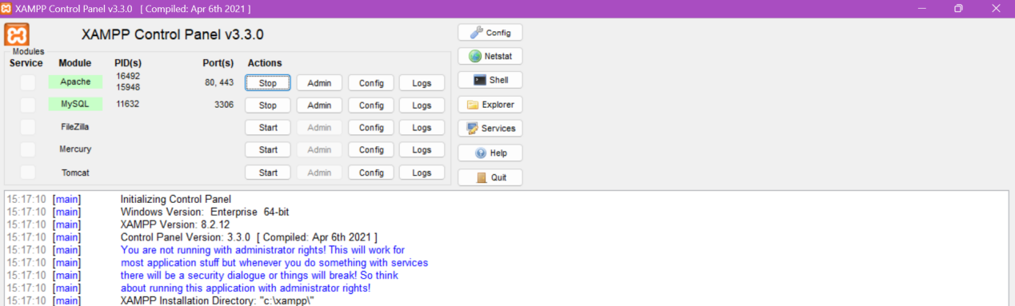

Fig 3:Browser showing `http://localhost/cheapmart/Week1/index.html` displaying “Welcome to CheapMart”.
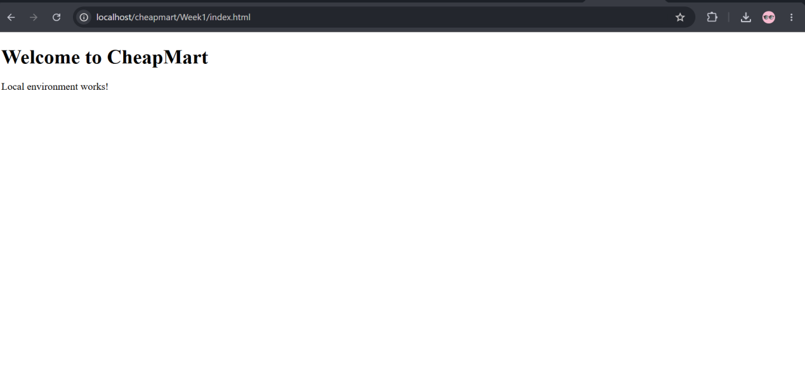
Fig 4: shows a successful Screenshot of first PHP or HTML page “Hello World”
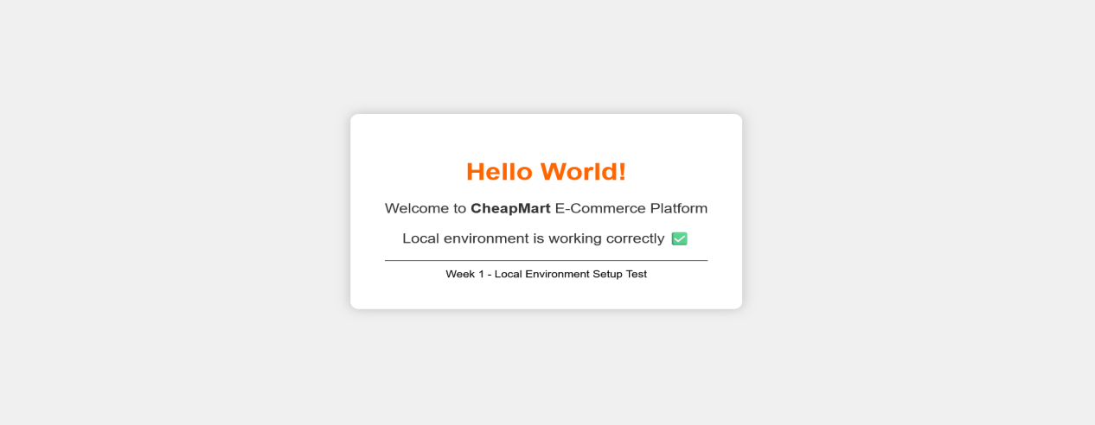
Fig 5: Browser showing `http://localhost/cheapmart/Week1/db_test.php` with message “Connected successfully to CheapMart database”.
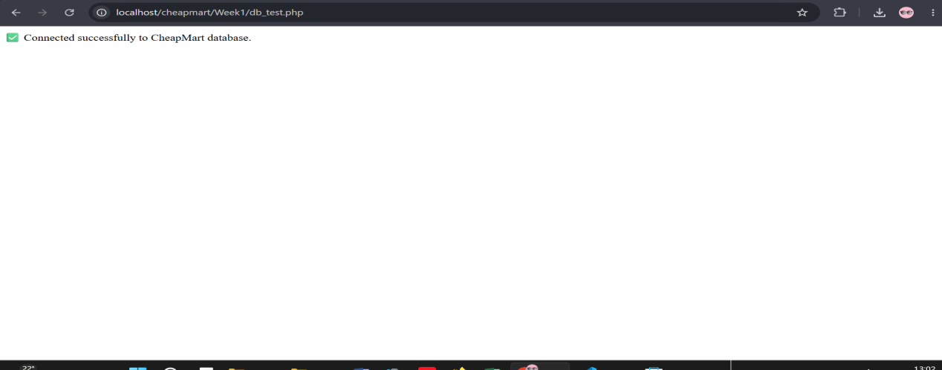
Student Reflection
This week I installed XAMPP and confirmed that both Apache and MySQL services run without errors. I created the project folder `cheapmart` and inside it a subfolder `Week1`. Writing a simple PHP `info.php` proved that the server can process backend code. The most important step was creating the `cheapmart` database in phpMyAdmin and writing a PHP connection script using `mysqli_connect()`. When I saw the success message , I knew the environment was ready for dynamic development. I also exported the empty database as as`Week1db.sql` and pushed everything to GitHub. No major issues – just had to ensure MySQL was on port 3306.

Week 2: Wireframes and GUI Design
Title:User Interface Planning and System Design
Fig 1: Hand‑drawn wireframe of the CheapMart homepage (header, hero section, product grid, footer).
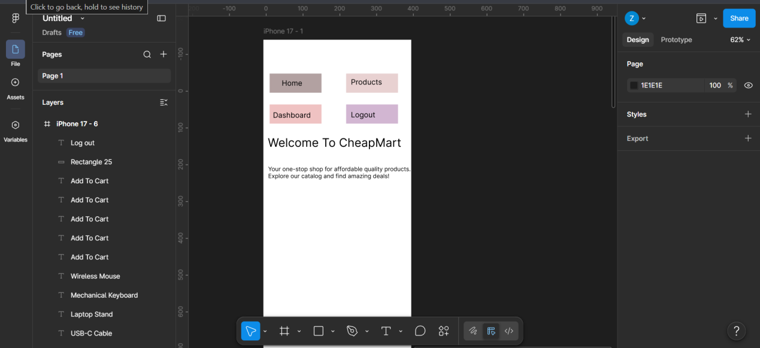

Fig 2: Wireframe of the login and registration page (two simple forms with links).
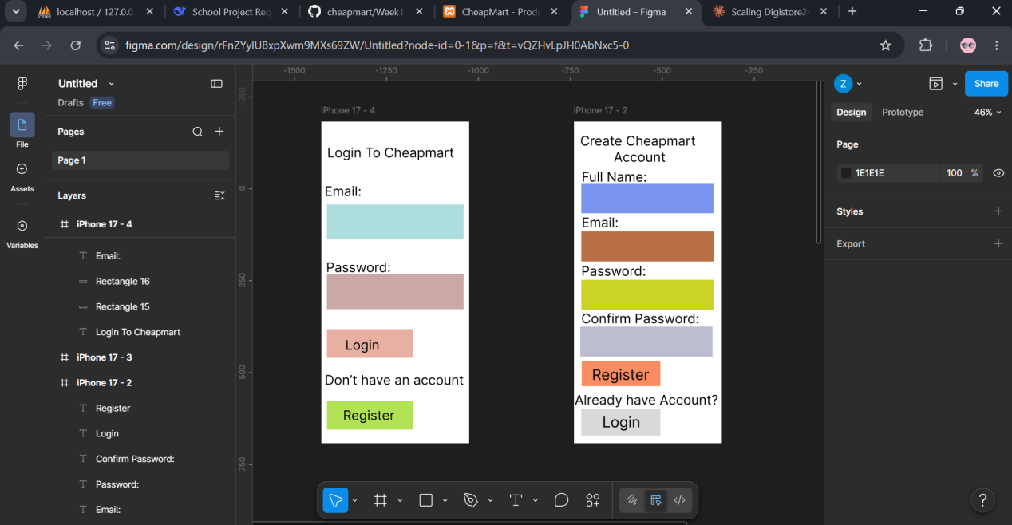

Fig 3:Mobile responsive view of the homepage

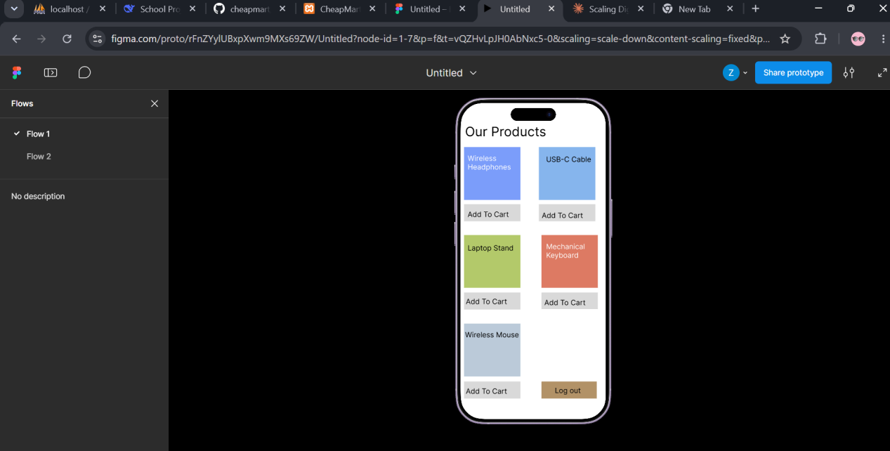
Fig 4: Color Theme and Navigation Structure

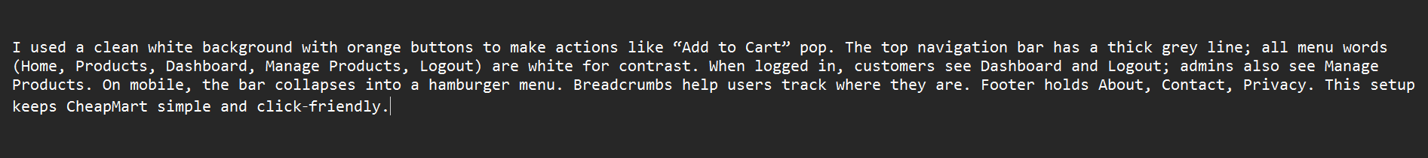
Fig 5: GUI Prototype in Figma/Canva/Draw.io
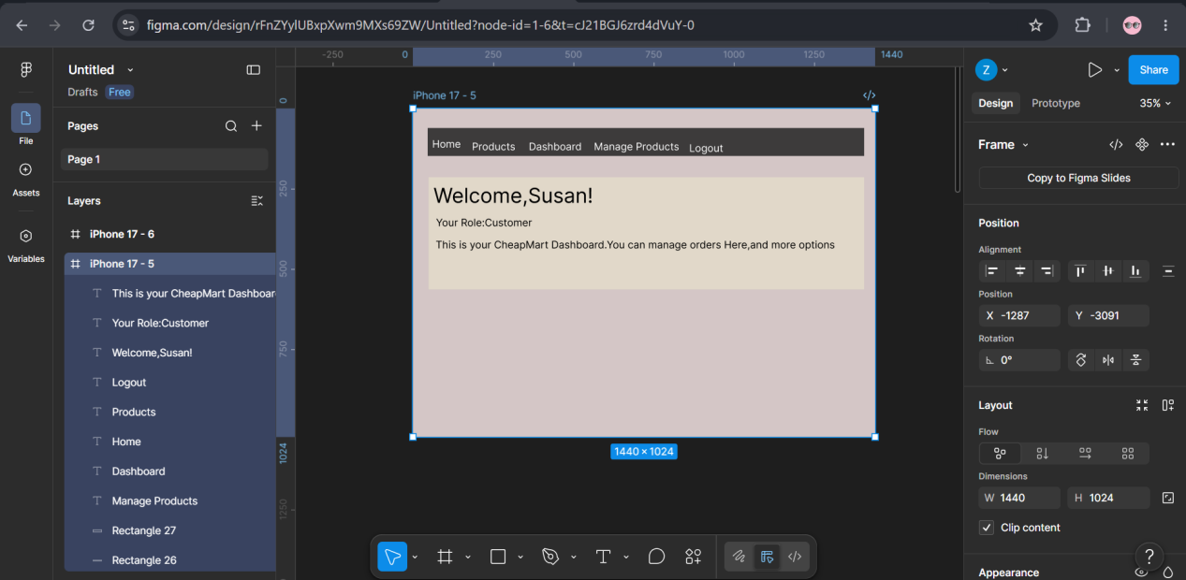

Student Reflection
During Week 2 I focused on translating user requirements into visual layouts. I started with hand‑drawn wireframes (Fig 1‑3) to quickly iterate on page flow and component placement. Then I moved to digital mockups using Canva, choosing an orange and dark blue colour scheme to convey affordability and trust. I designed a product catalog page (Fig 4) with card‑based layout and a visible search bar. Creating a mobile responsive view (Fig 5) taught me to think about navigation on small screens – I used a collapsible menu. Finally, I planned the project folder structure (Fig 6) to keep code organised from the start. This week showed me that good design saves debugging time later.

Week 3: JavaScript and PHP Basics
Title: Frontend Interaction and Backend Foundations
Fig 1:Javascript form validation-empty filled errors

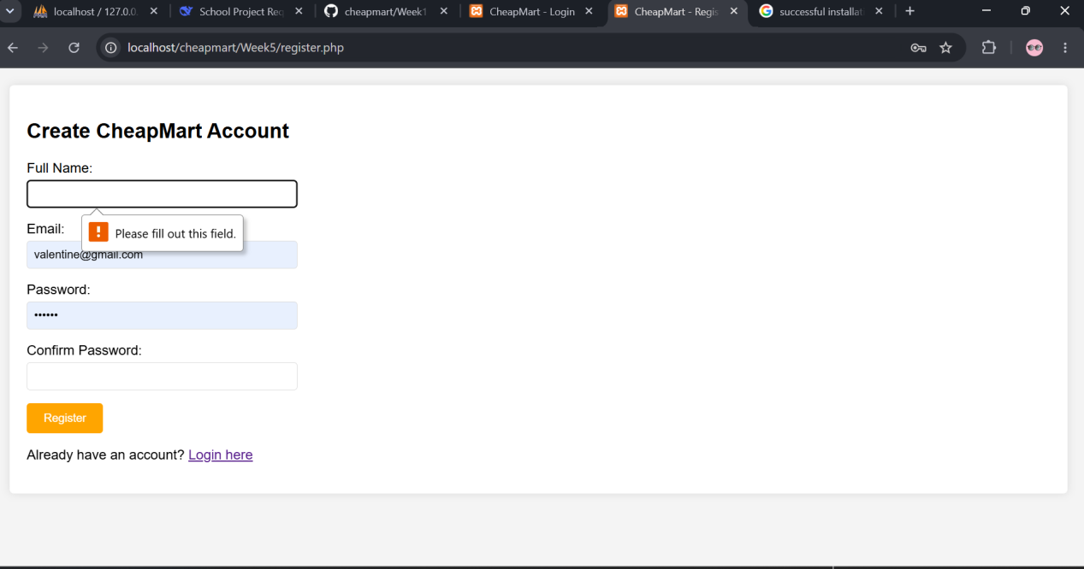
Fig 2: Password strength checker displaying “Weak password” when user types “123”.
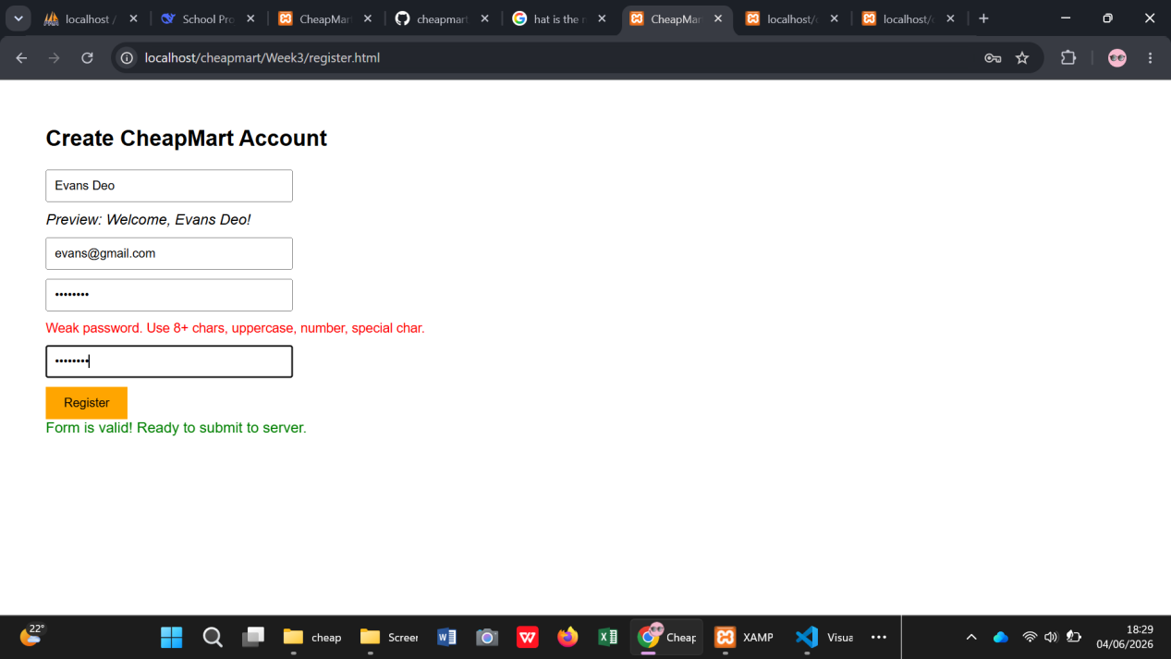

Fig 3:Email validation – invalid email (e.g., “test@” ) triggers an error. PHP syntax Practice
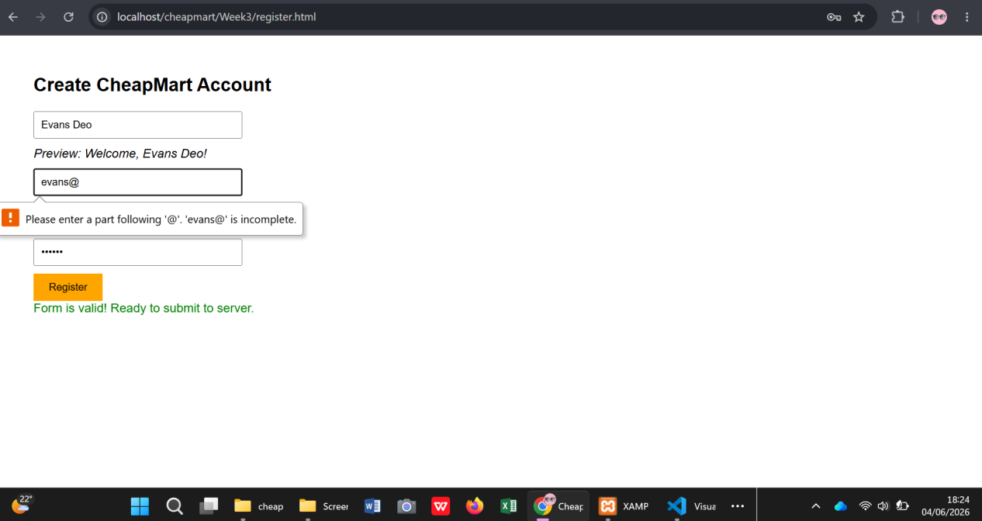

Fig 4:Live text preview – as I type my name, a paragraph below shows “
Welcome, [name]!”.

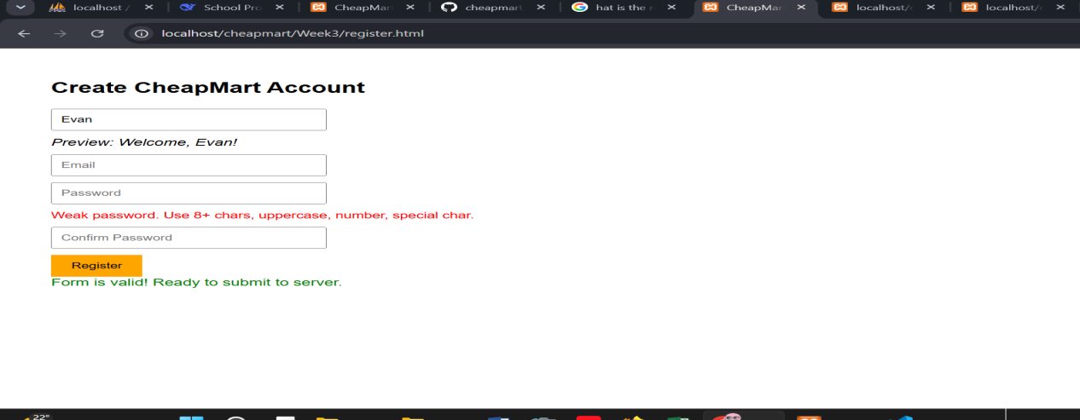
Fig 5: PHP script `process_register.php` output after a successful simulated registration.

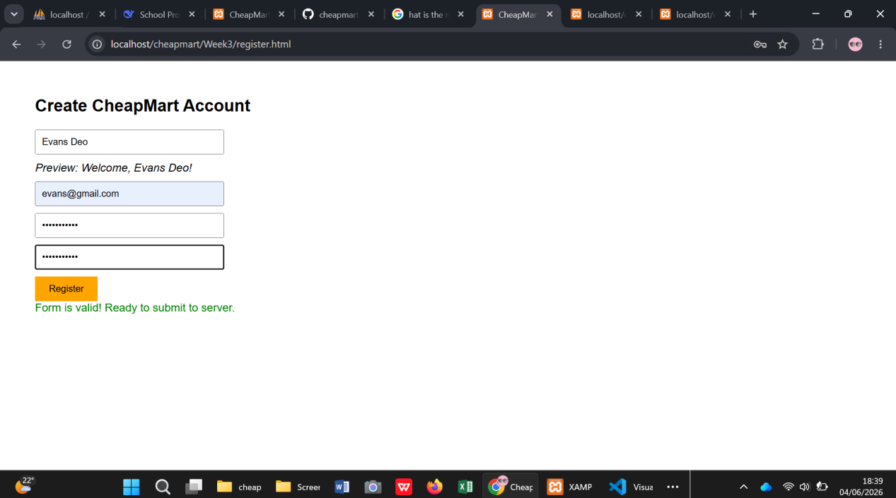

Fig 6: Database connection script `db_connect.php` displaying “Connected successfully to CheapMart database”.
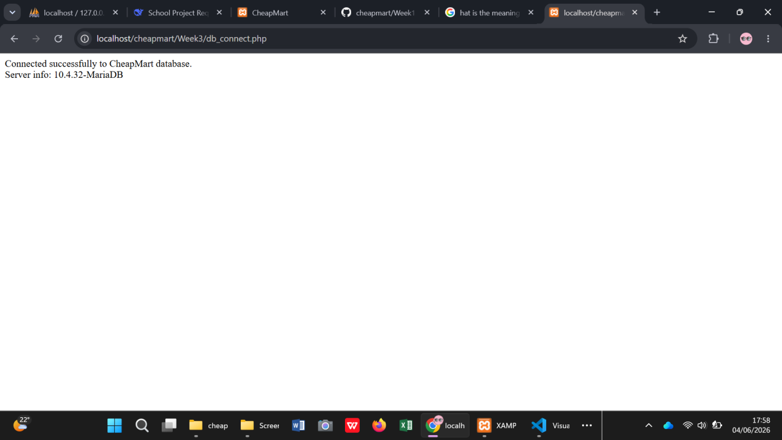

Fig 7: `Week3db.sql` file saved inside the Week3 folder (screenshot of File Explorer).
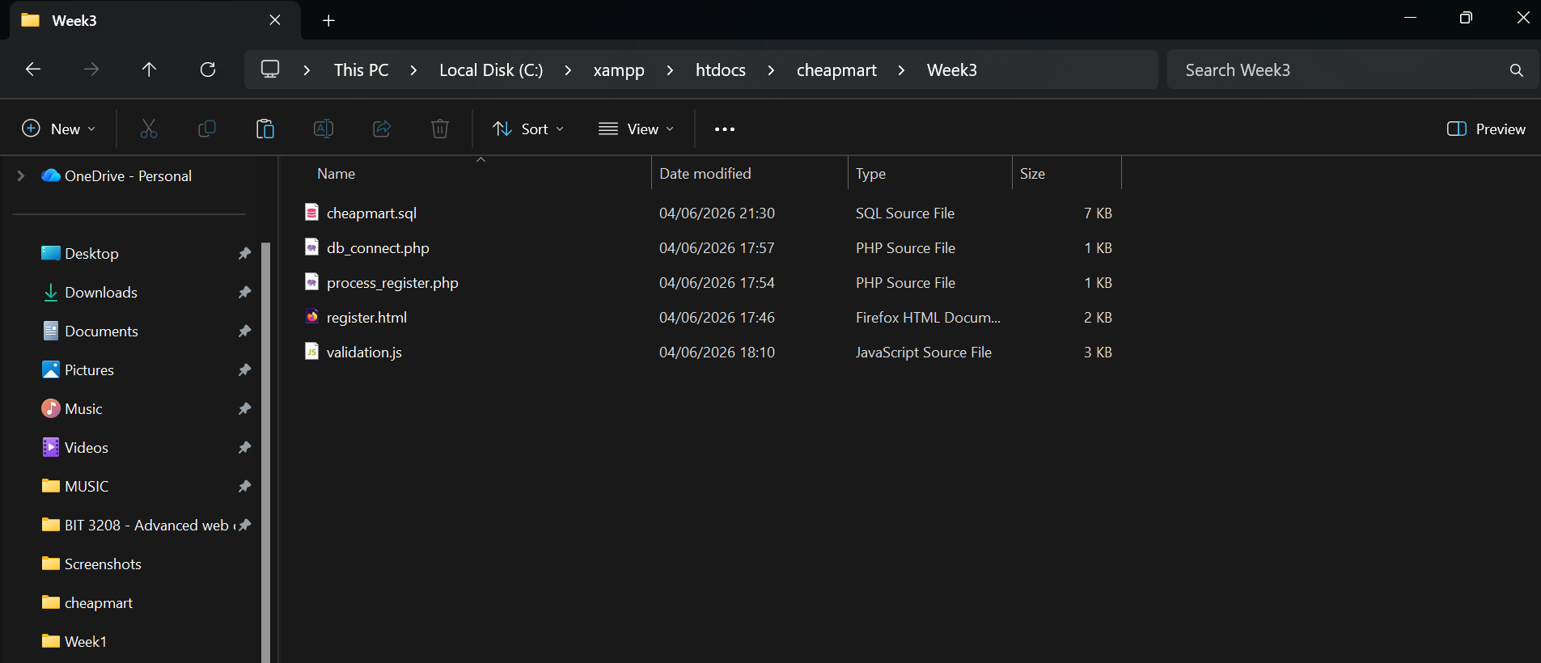

Student Reflection
Week 3 was my first hands‑on coding week. I built a registration form with JavaScript validation (Fig 1‑3). I learned to check for empty fields, validate email patterns, and measure password strength using a simple scoring function. The live text preview (Fig 4) showed how DOM manipulation can improve user experience instantly. On the server side, I wrote a PHP processor that receives form data and simulates registration (Fig 5). I also created a reusable database connection script (Fig 6) that I will include in every backend page later. Exporting `Week3db.sql` (Fig 7) continued my incremental backup habit. I struggled with getting the password strength function to be strict enough, but after testing different regex patterns, it worked reliably.

Week 4: Server‑Side Components and Authentication
Title:Server‑Side Components and Backend Development Foundations
Fig 1:Registration form in `register.php` – after submitting, a success message appears.
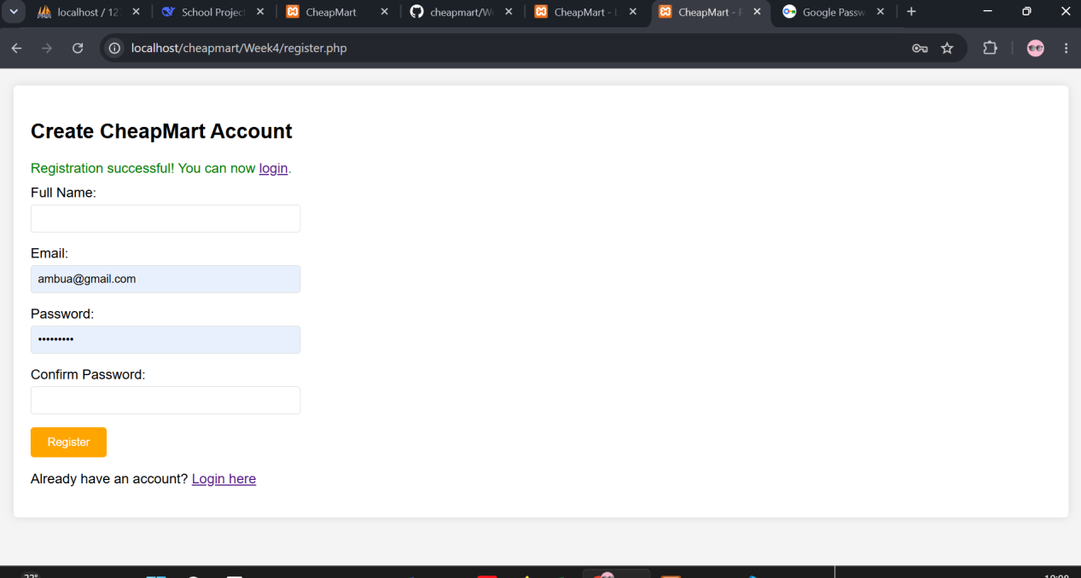

Fig 2:Login form in `login.php` – entering wrong credentials shows red error.
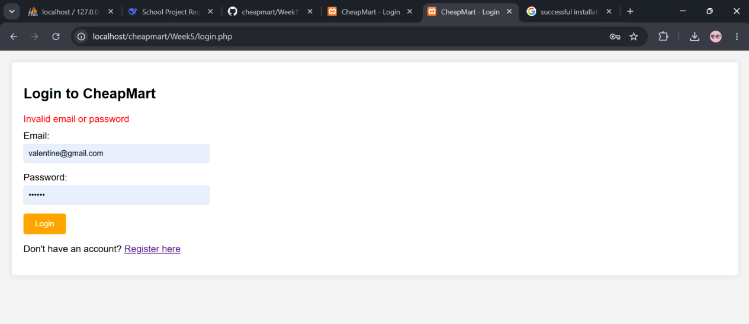.

Fig 3:After successful login, the dashboard (`dashboard.php`) shows your role.
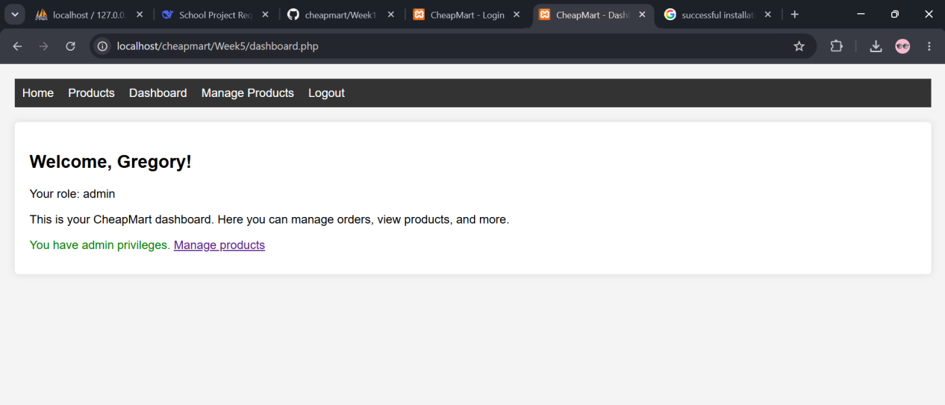

Fig 4:Admin dashboard view – additional “Manage Products” link appears.
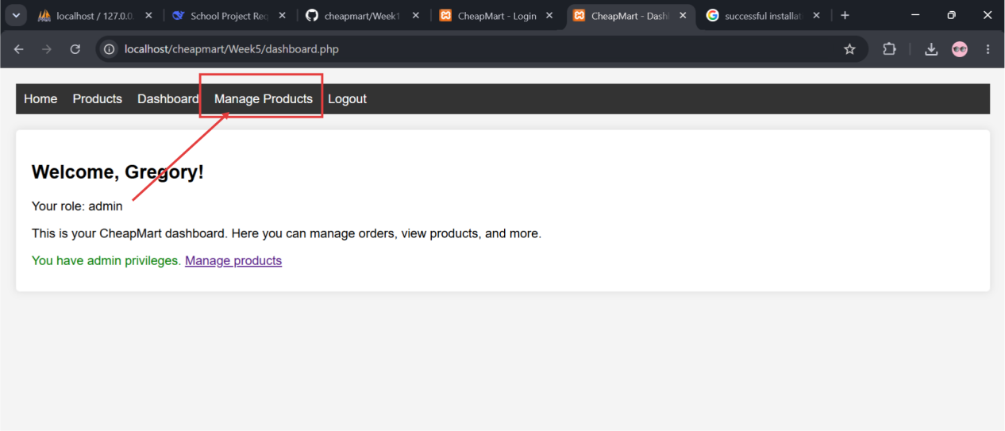

Fig 5:Session persistence – after logging in, navigating to `index.php` shows “Dashboard” and “Logout” instead of “Login/Register”.
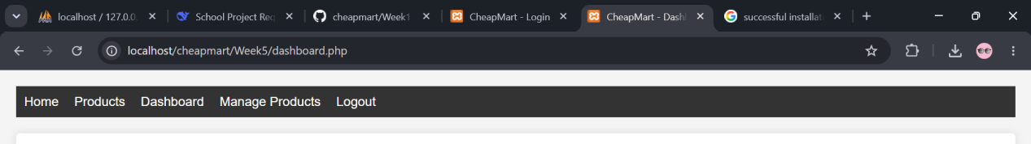

Fig 6: Folder structure of `Week4` with subfolders `includes/`, `css/`, `js/`.
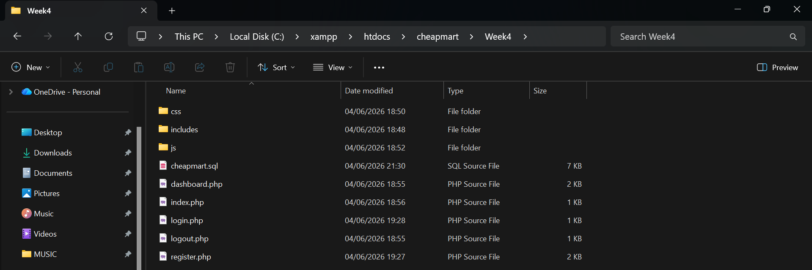

Fig 7:`Week4db.sql` exported from phpMyAdmin inside the Week4 folder.
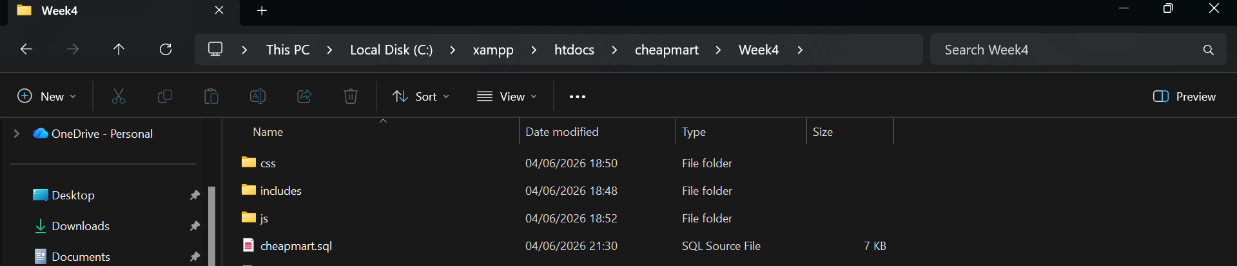

Student Reflection
This week I moved from static forms to a full authentication system using PHP sessions. I structured the project with an `includes/config.php` file that starts the session and connects to the database. In `register.php` I added server‑side validation and inserted user data (for now, into a hardcoded array because the database table wasn’t ready). For login, I compared credentials against that array and stored `$_SESSION` variables upon success. The dashboard checks for a logged‑in session; if not, it redirects to login (Fig 5 shows the effect). Role‑based access was implemented by storing `user_role` in the session. I learned that sessions are stored on the server and only a session ID travels to the browser. The biggest challenge was ensuring the session started on every page – solved by putting `session_start()` inside the config file.

Week 5: Database Components and CRUD Operations
Title:Database Components and CRUD Operations
Fig 1:phpMyAdmin showing the five tables (`users`, `products`, `carts`, `orders`, `order_items`).

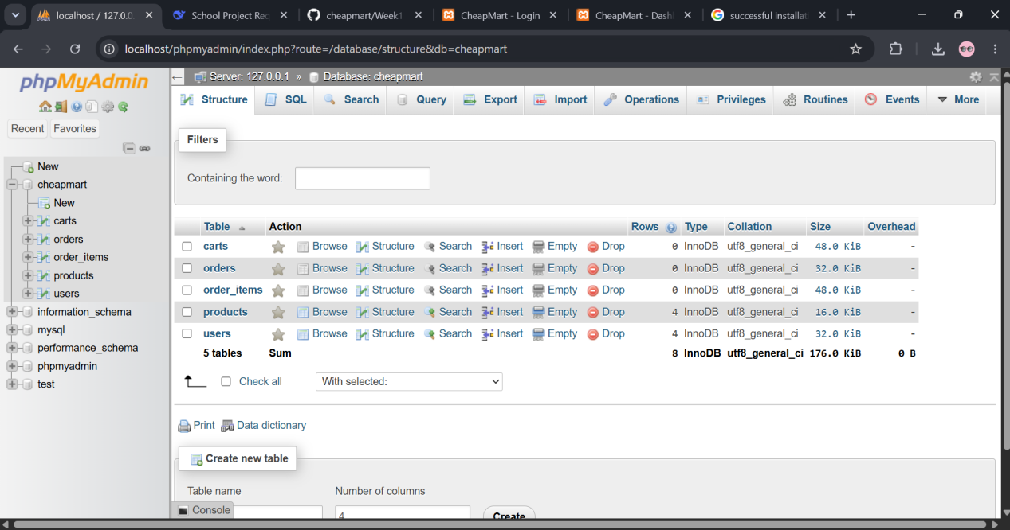

Fig 2: The `users` table after registration – a new row with hashed password.
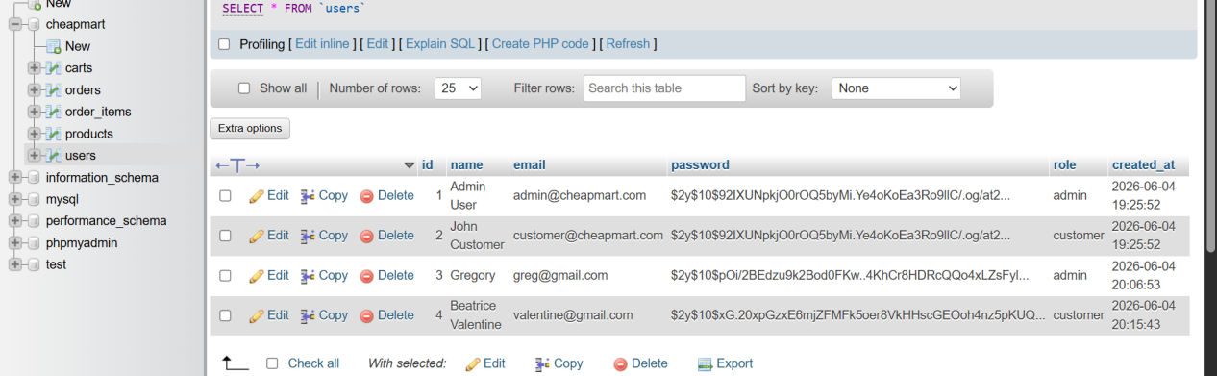

Fig 3:Login using the database‑stored credentials – dashboard shows correct user name.
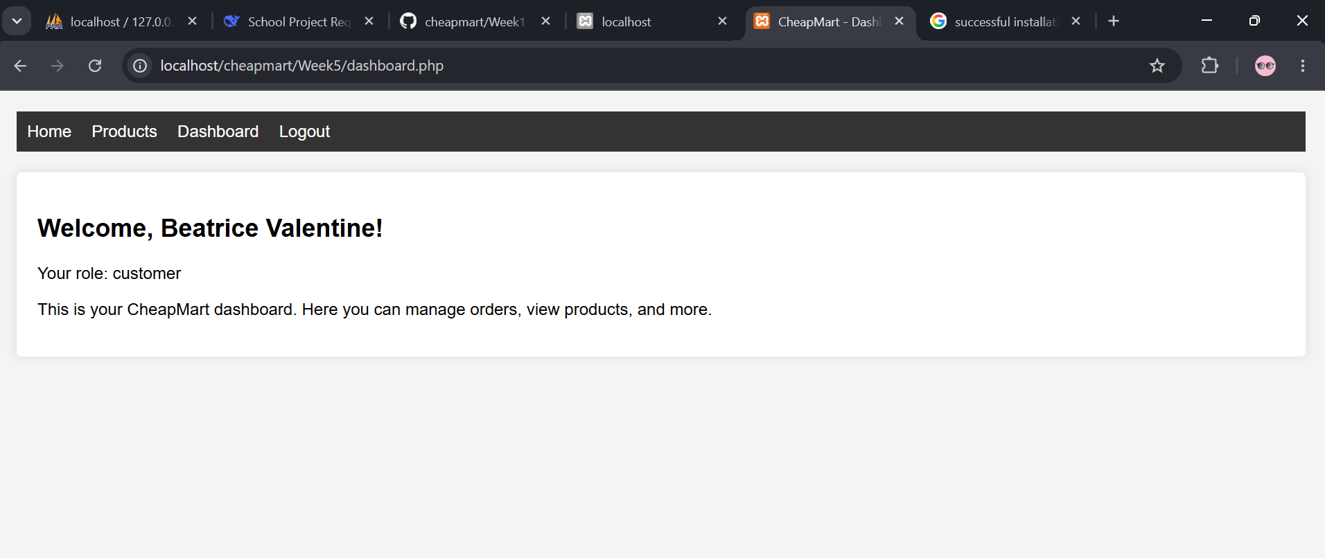
Fig 4: Admin product list page (`admin_products.php`) showing all products in a table.
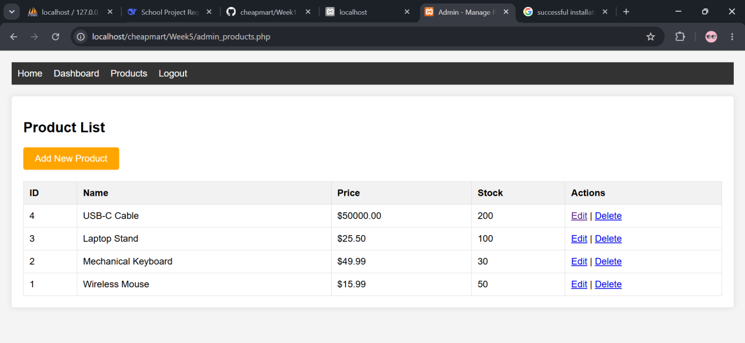

Fig 5: Add product form – filling details and clicking submit.
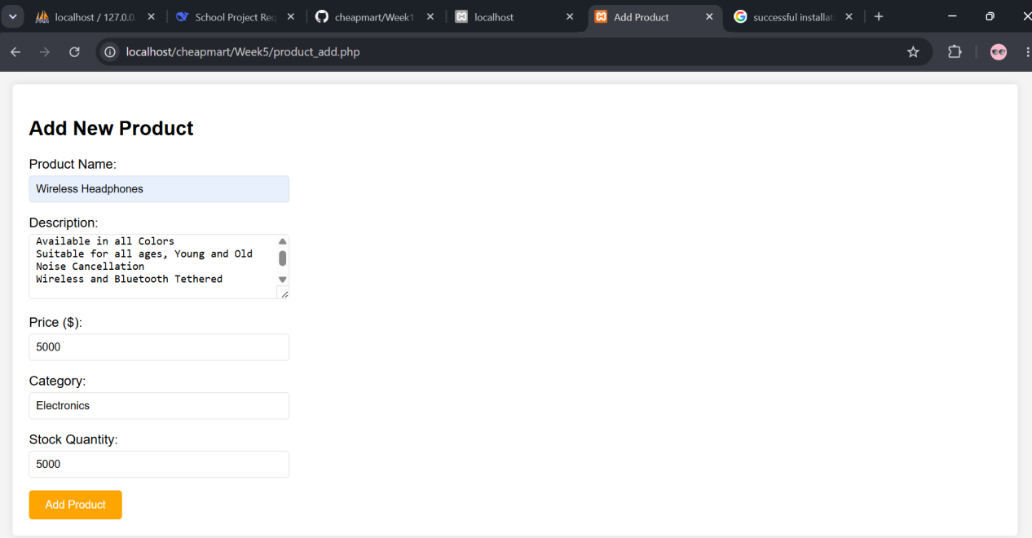

Fig 6: Edit product page – changing the price of a product.
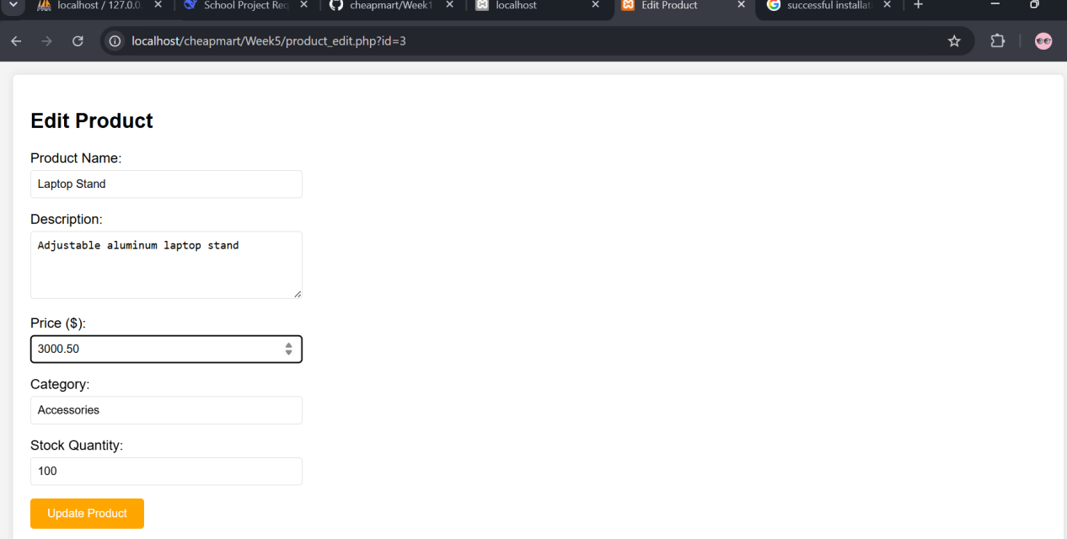

Fig 7: Delete confirmation popup – browser’s confirm dialog appears.
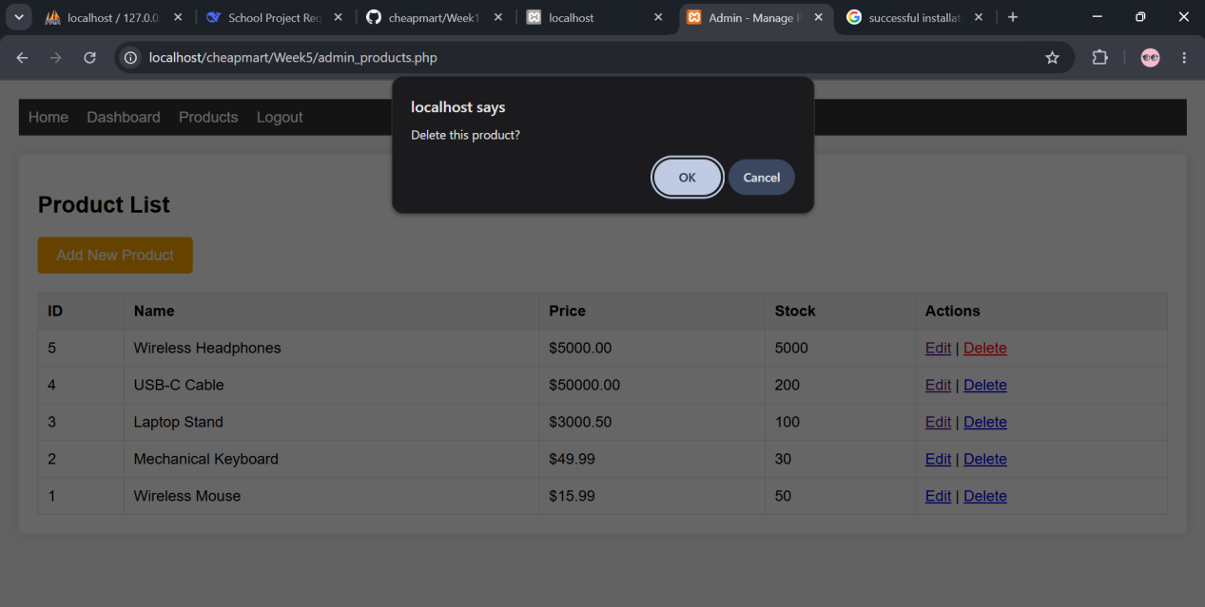

Fig 8: Customer product catalog (`catalog.php`) displaying products from the database.

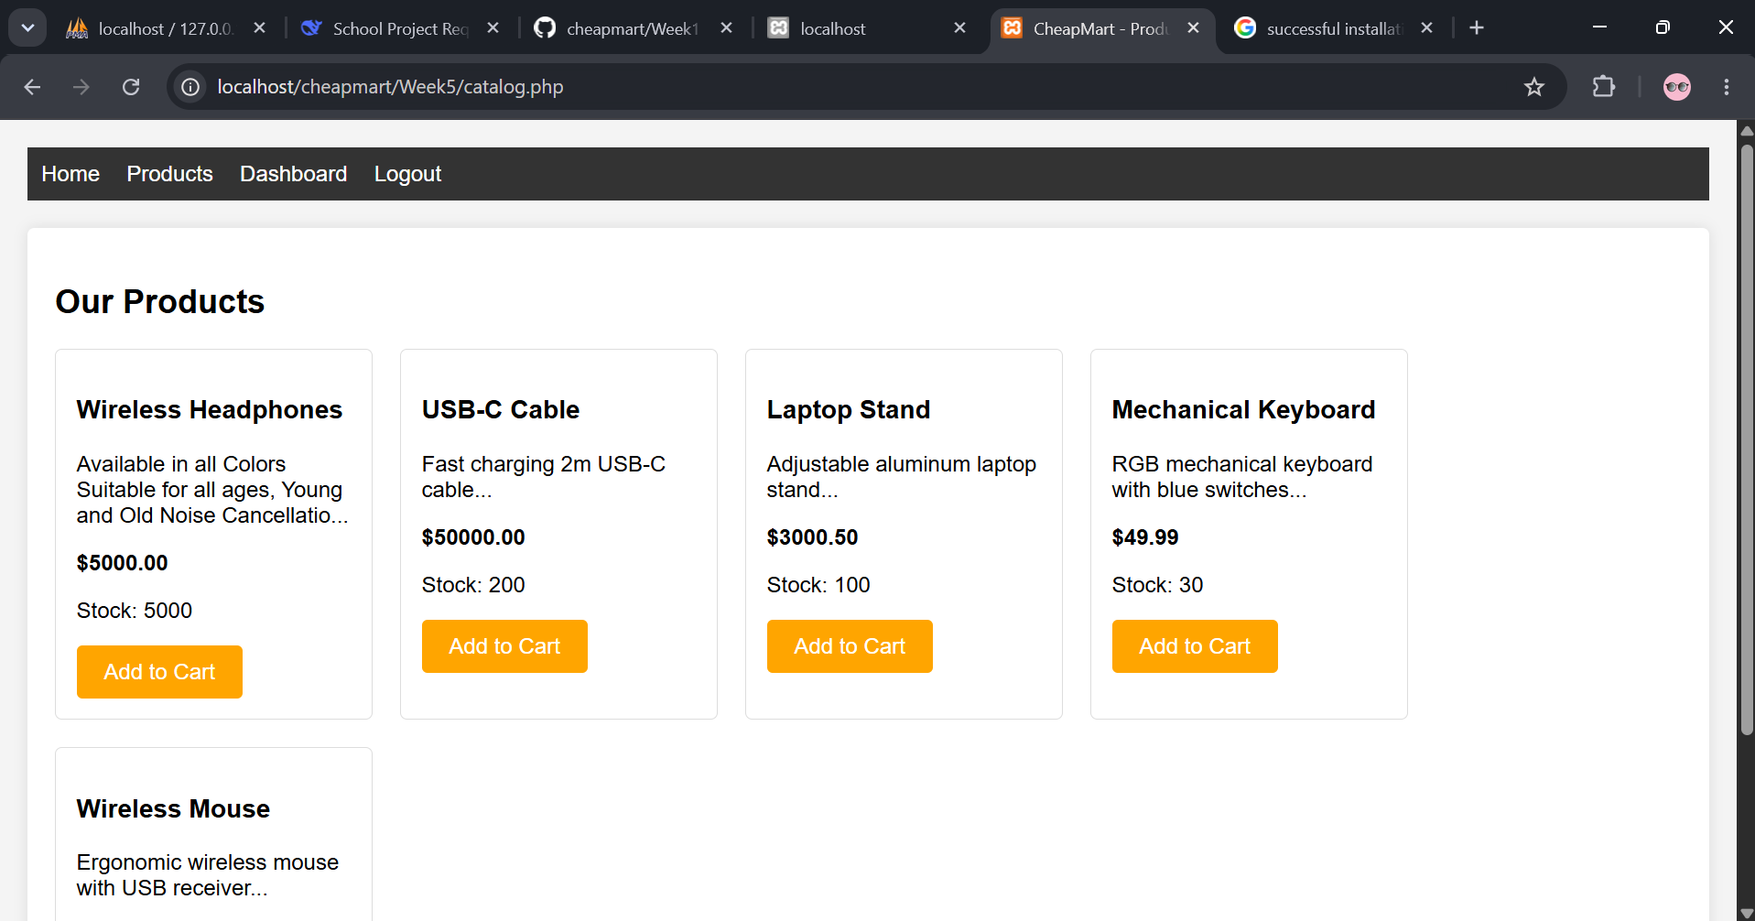

Fig 9: `Week5db.sql` file saved in the Week5 folder (File Explorer view).
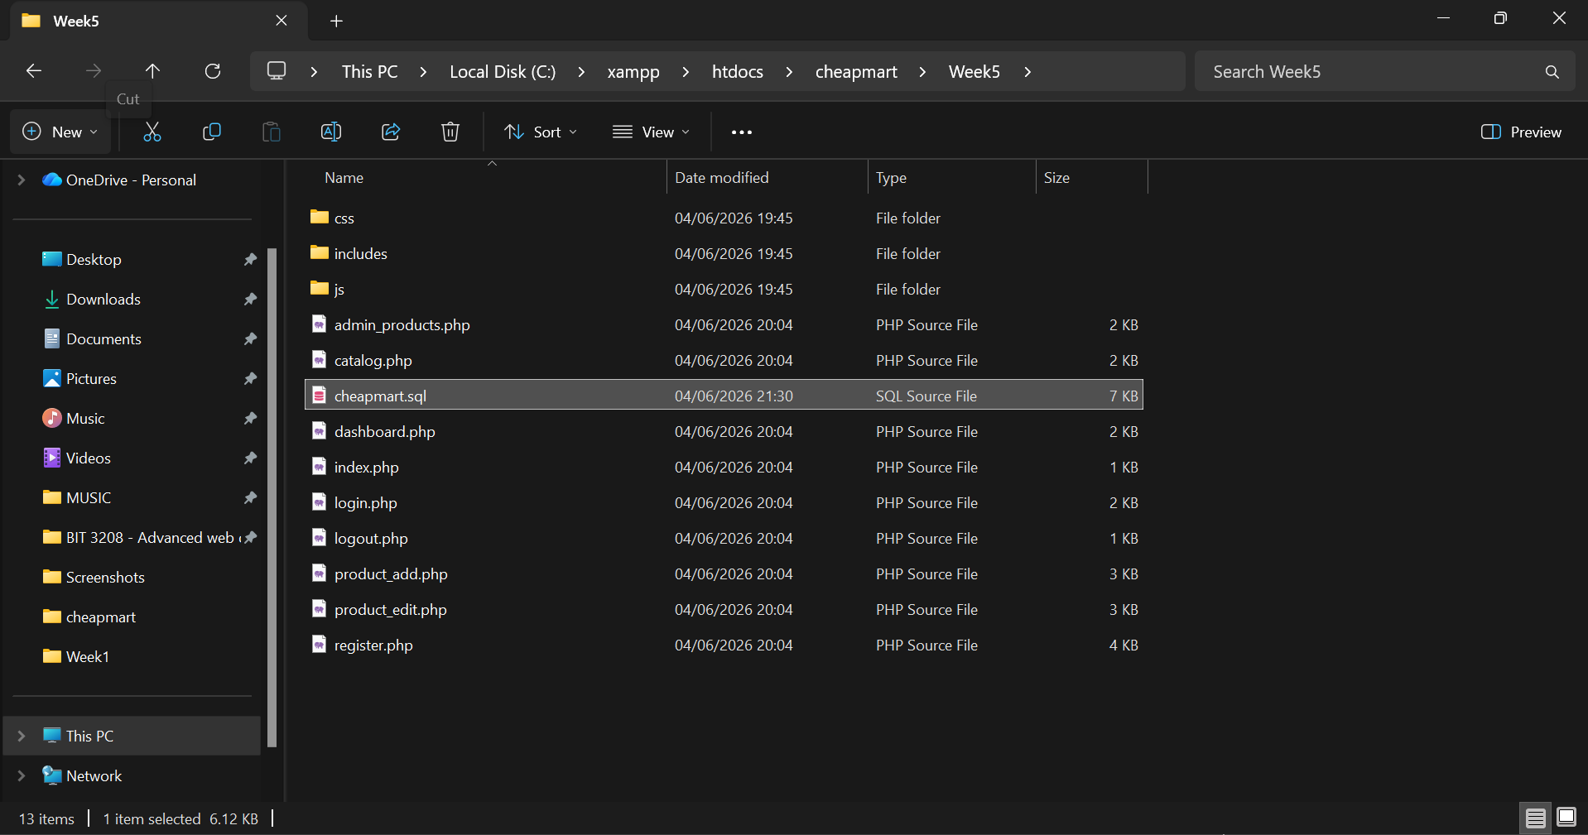

Student Reflection
Week 5 was the core database integration. I created five relational tables with foreign keys, which taught me how e‑commerce platforms structure data. I updated `register.php` to insert into the `users` table using `password_hash()` and `login.php` to verify with `password_verify()`. For admin, I built complete CRUD operations: listing products, adding a new product (Fig 5), editing details (Fig 6), and deleting with confirmation (Fig 7). The customer catalog (Fig 8) now reads dynamically from the `products` table. I learned to use prepared statements to prevent SQL injection – every query that accepts user input goes through `mysqli_prepare`. Exporting `Week5db.sql` (Fig 9) ensures I have a full backup with data. This week made the system truly database‑driven.

